SDV602 – Assessment 2

## Data Explorer Screen Application

## Alex Herbert

## 6/10/2024

### Project Brief and Description

The purpose of this project is to design and develop an application that can be used by data analysts to view graphs displaying visual representations of data, as well as the implementation of a chat system that can be used for communications between the data analysts. The application includes three separate Data Explorer Screens that are used to display the graphs in a Graphical User Interface (GUI), these screens are navigable and contain a placeholder for “Chat Windows”. The graphs displayed will have placeholder/mock data that is accessed locally to provide an example of the usability of the application.

While this project is a prototype and does not reflect the finished version of this application, the architectural design will become the foundation of the final product and has been designed accordingly. This application is intended to be used in conjunction with an http-based API, connecting to a remote data service, allowing the chat functionality to be used outside of an organization’s physical location or within their internal network.

### Application Story Board and Wireframe Designs

To correctly determine the functional requirements for the application and types of user interactions with the software’s GUI, the following story board and wireframe designs provide a visual representation and description of the applications use cases and functionality.

### Functional Requirements

* Application must have a Main Menu and three DES windows with different graphs.
* User must be able to cycle through different screens using GUI navigation.
* User must be able to upload and select data sources to the application to be displayed in graphs.
* The application GUI must include a Graph Summary Information section.
* The application GUI must include a user Chat window, allowing users to communicate with each other using the chat functionality.
* The application must be able to be connected to an http-based API.
* Graphs in the application must be configurable and include a Zoom in and out functionality.

### Wireframe Designs

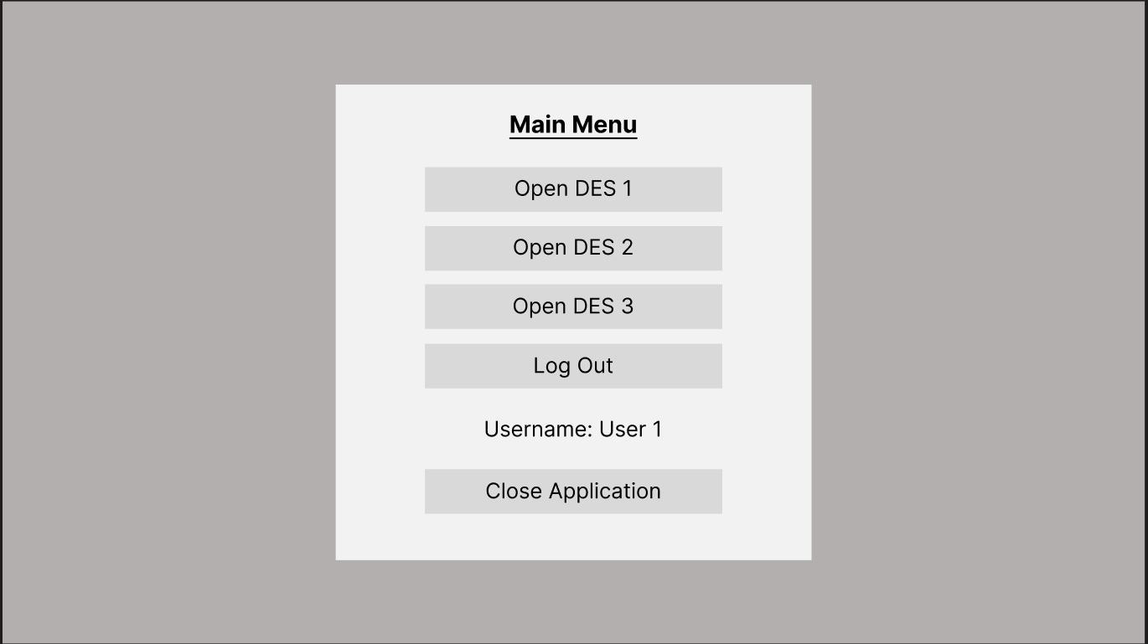

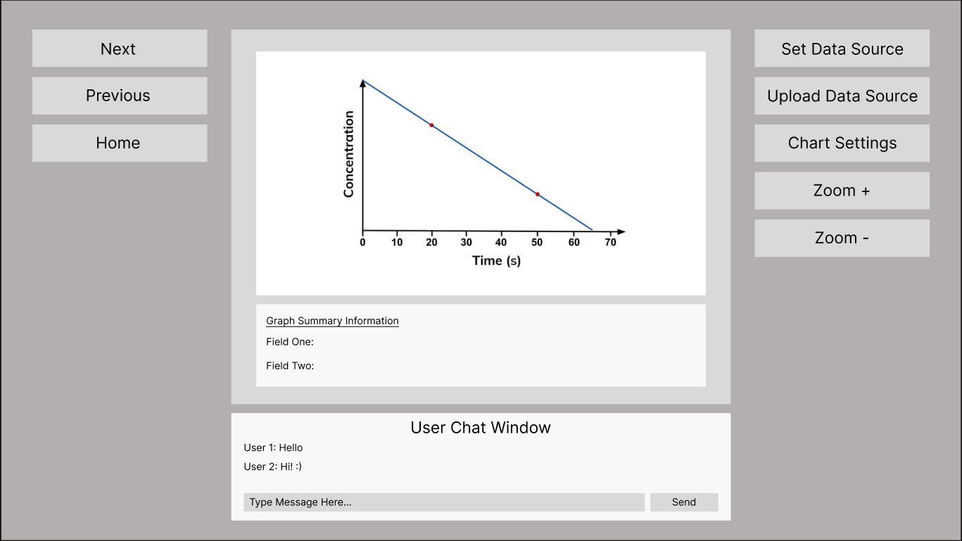

### User Story One – User selects DES 1 button from Main Menu

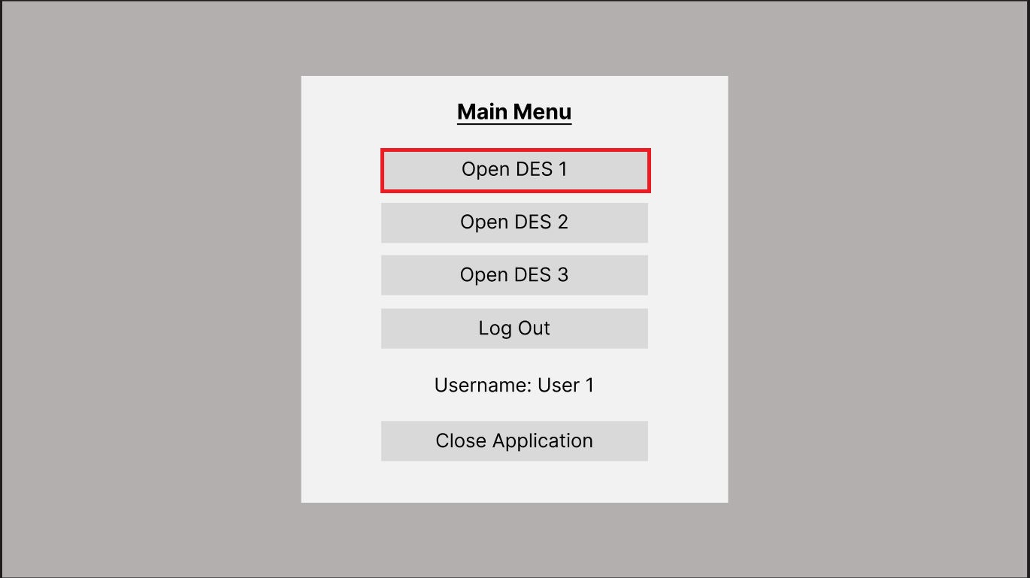

The user opens the application and is presented with the main menu, from here the user then selects the “Open DES 1” button which opens/loads the DES 1.

### User Story Two – User logs out of their account using “Log Out” Button

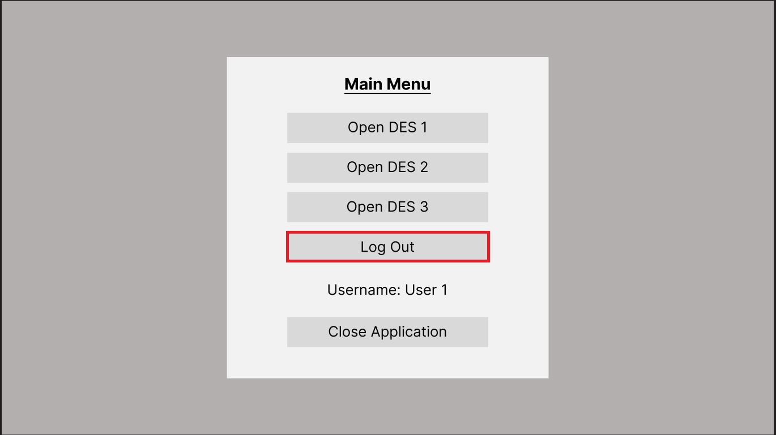

When presented with the main menu, the user logs out of their account by selecting the “Log Out” button, for this prototype this functionality is a placeholder.

### User Story Three – User Closes the Application by selecting the “Close Application” button

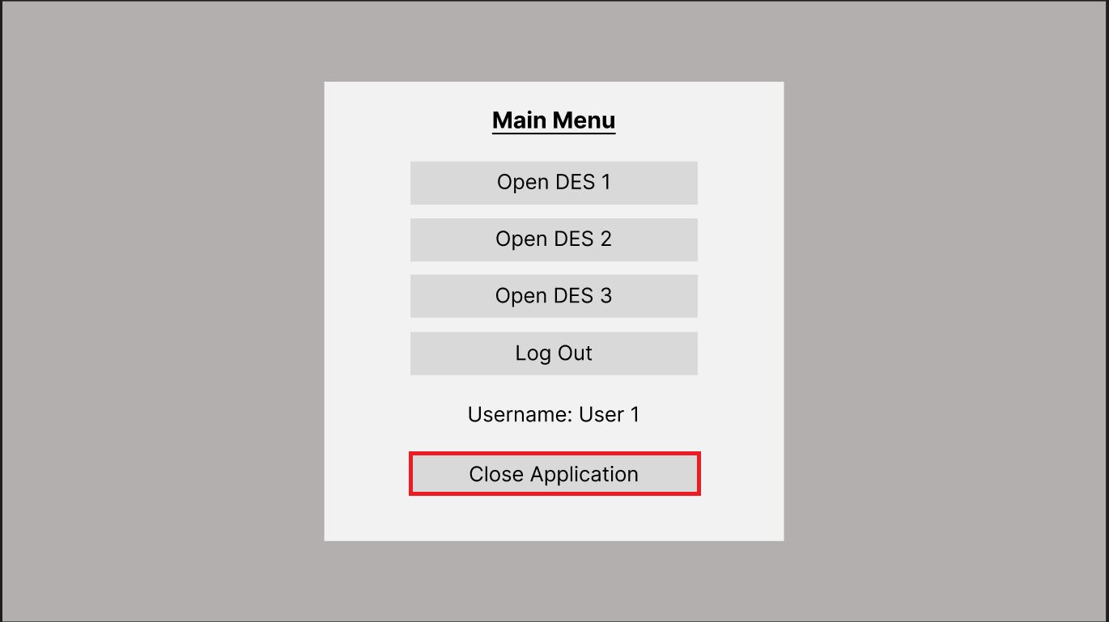

To close the application, the user selects the “Close Application” button, this closes any of the active screens and terminates the application.

### User Story Four – The user uploads a new data source for use by the graph on active screen

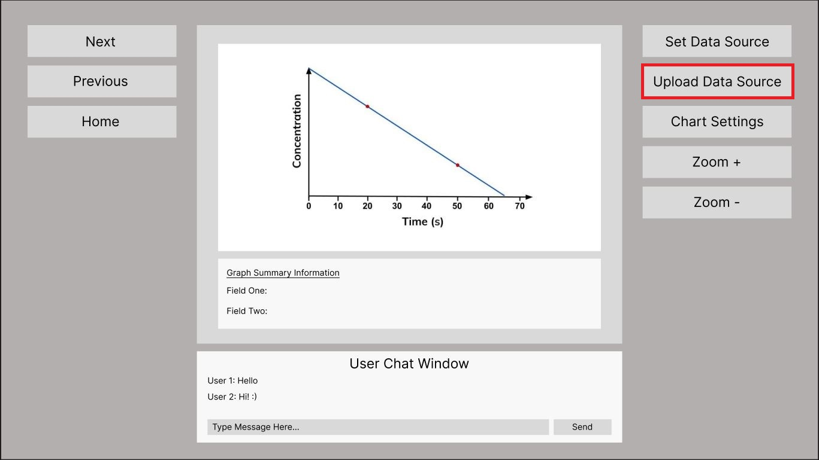

The user selects the “Upload Data Source” button, which then presents a window allowing them to select and upload an appropriate file that can accessed by the graph.

### User Story Five – User set’s the data source to be accessed and displayed by the graph on active screen

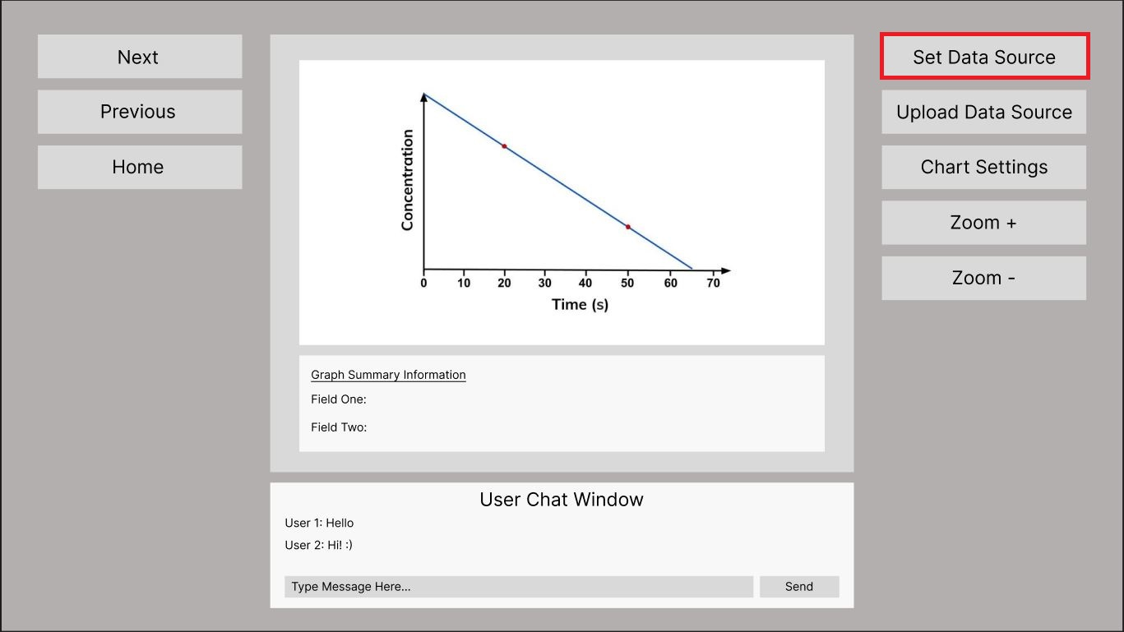

Once the user has uploaded a data source to be accessed by the graph on the active DES, the user then selects the “Set Data Source” and selects the uploaded file, the data from this file is then processed and loaded into the graph on the active screen.

### User Story Six – User changes the active screen using the “Next” or “Previous”

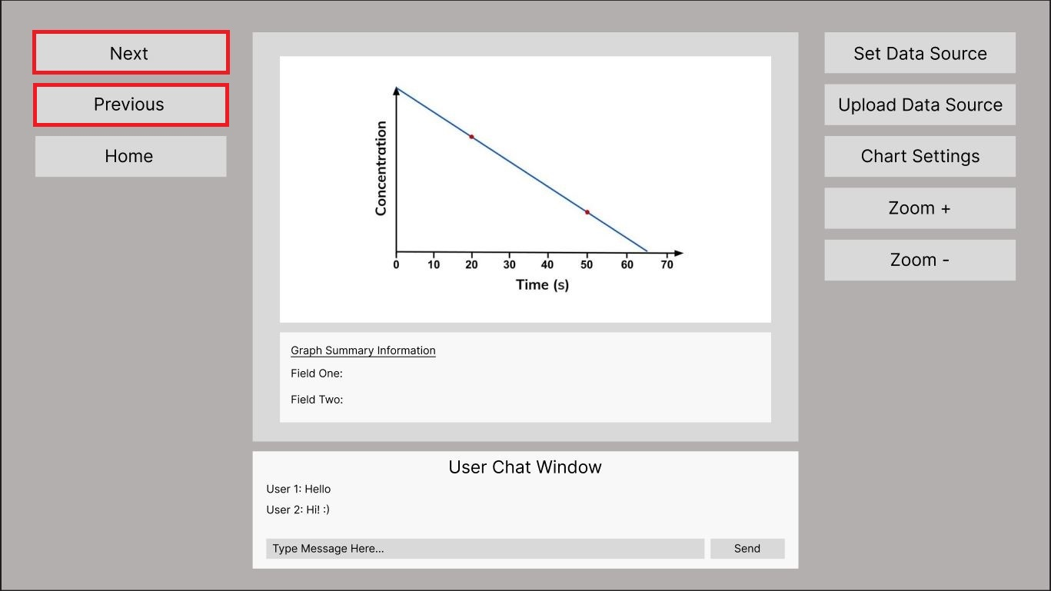

The user cycles through the three Data Explorer Screens by selecting either the “Next” or “Previous” buttons in the application GUI, this loads and displays the DES according to the screen that is active.

### User Story Seven – User reviews the DES graph displayed and graph summary information panel

### 

The user uploads a data set and sets it using the appropriate controls in the application GUI, the data is the visualised and displayed in the graph panel on the active DES to be reviewed by the user.

### User Story Eight – User types a message into the User Chat Window and sends the message to other users logged into the application

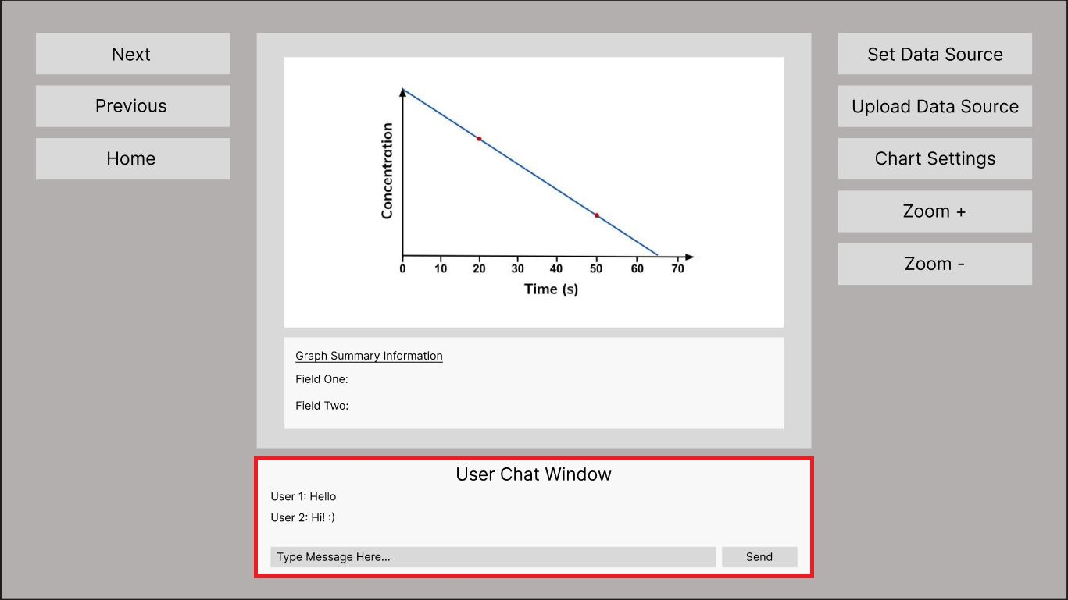

The user is logged into the system using their credentials, whilst interacting with the active Data Explorer Screen the user types a message into the User Chat Window and sends a message. This message is received and displayed to other users that are currently logged into the system.

### User Story Nine – User Zooms in or out of the graph displayed in the DES by using the “Zoom +” or “Zoom -“ buttons in the GUI

The user wants to increase and decrease the viewing size of the graph displayed in the active Data Explorer Screen, they select either the “Zoom +” or Zoom –“ button which increases or decreases the viewing size of the graph that is displayed.

### User Story Ten – The user changes the settings of the graph by selecting the “Chart Settings” button to change the ranges and values displayed.

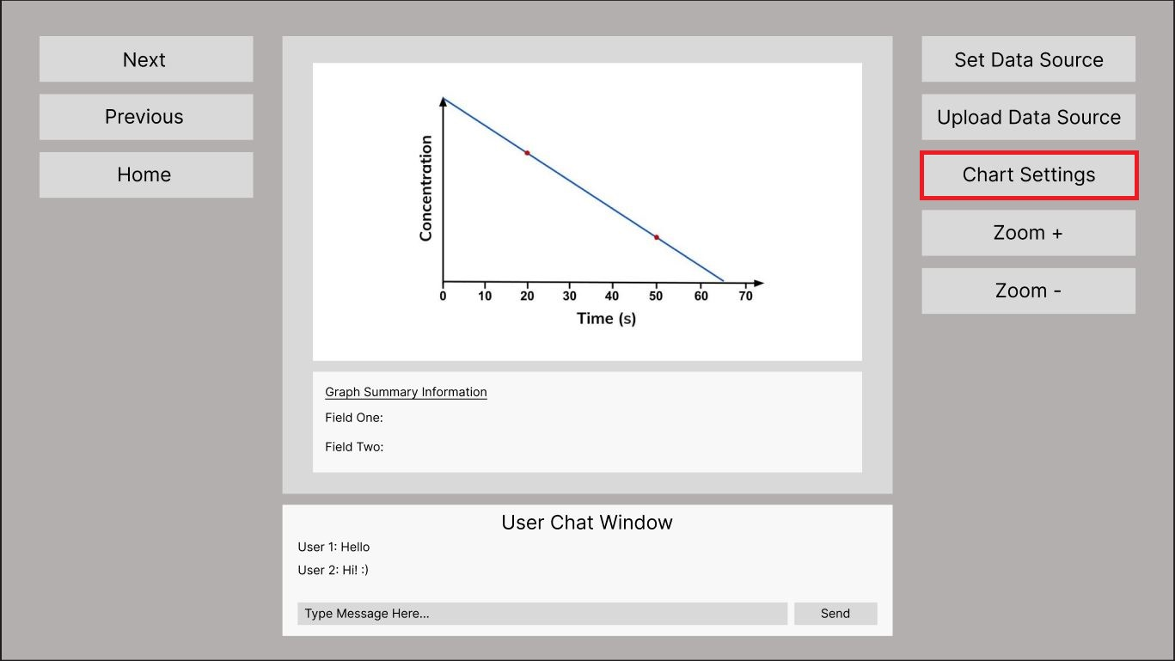

The user selects the “Chart Settings” button on the GUI, this then presents the chart settings menu which allows the user to change the values and ranges displayed on the graph.

### User Story Eleven – The user selects the “Home” button on the active DES interface to return to the main menu

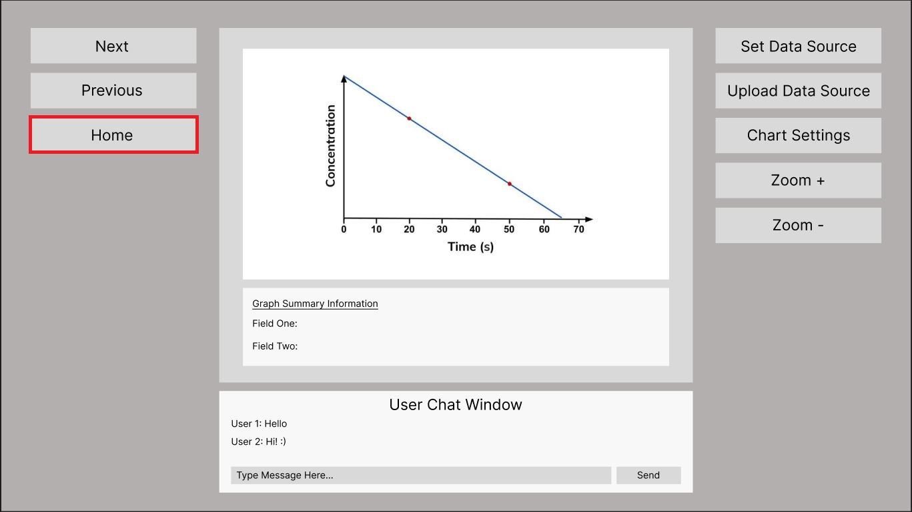

The user selects the “Home” button on the active DES interface they are working on to return to the main menu, this closes all active screens and displays the main menu.

## Test Scripts and Code Implementation

The following scripts and code examples are the initial prototype implementation of the project application, some buttons and functionalities are currently place holders and do not function as they would in the final product. This prototype is to show an example of how this application can be used by data analysts to review an organizations data with graphs and visualizations of the data in a readable and user-friendly interface.

Main.py

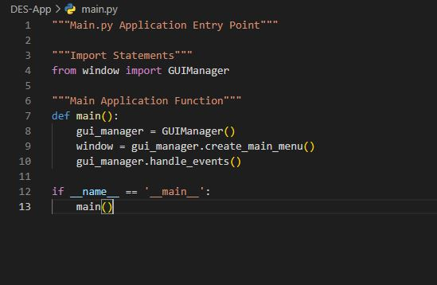

Charts.py

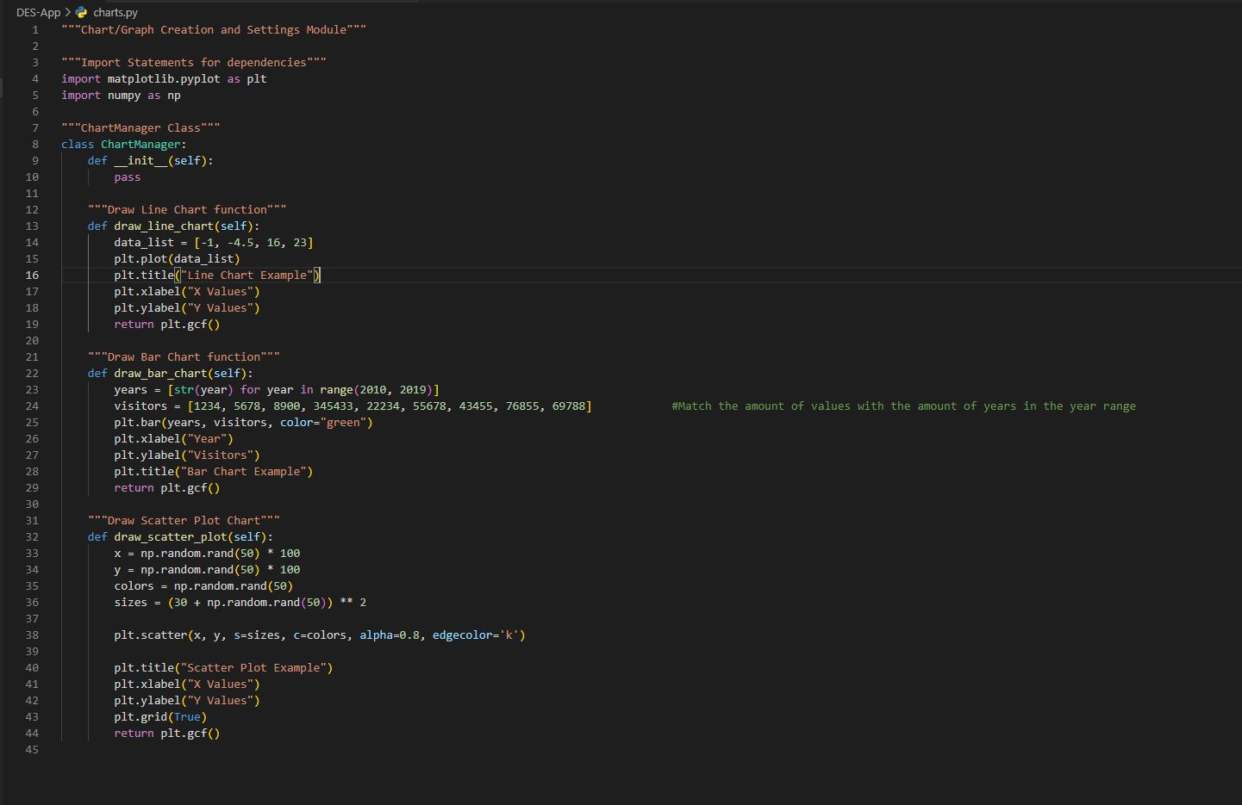

Windows.py Part 1

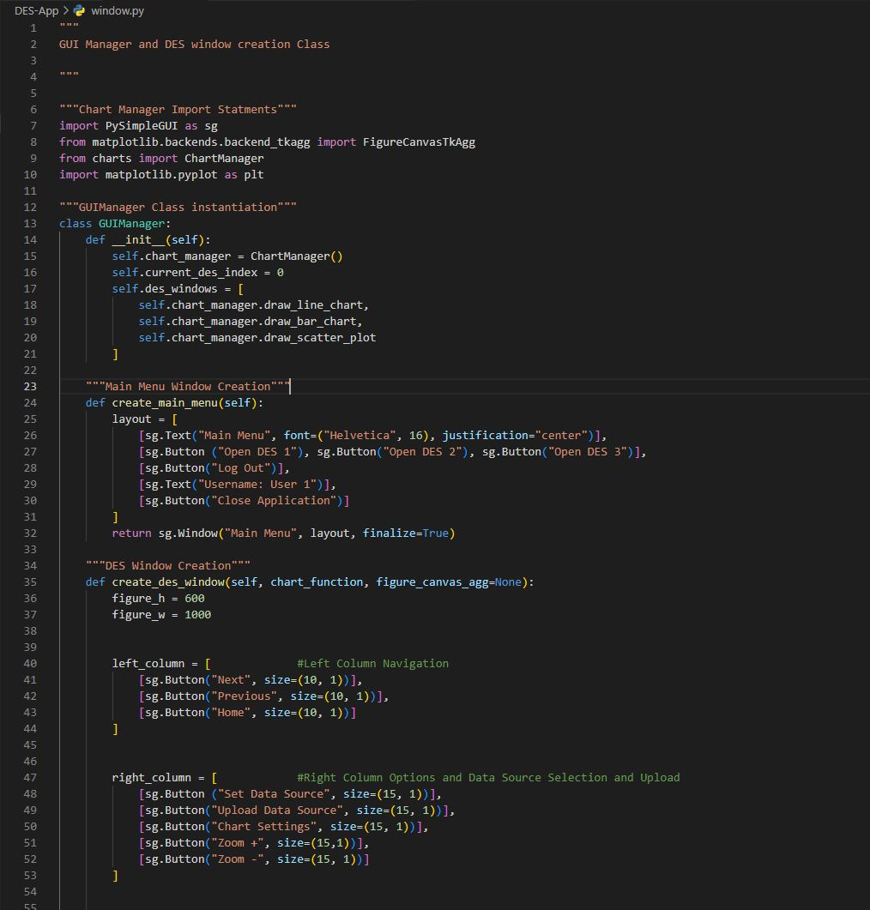

Windows.py Part 2

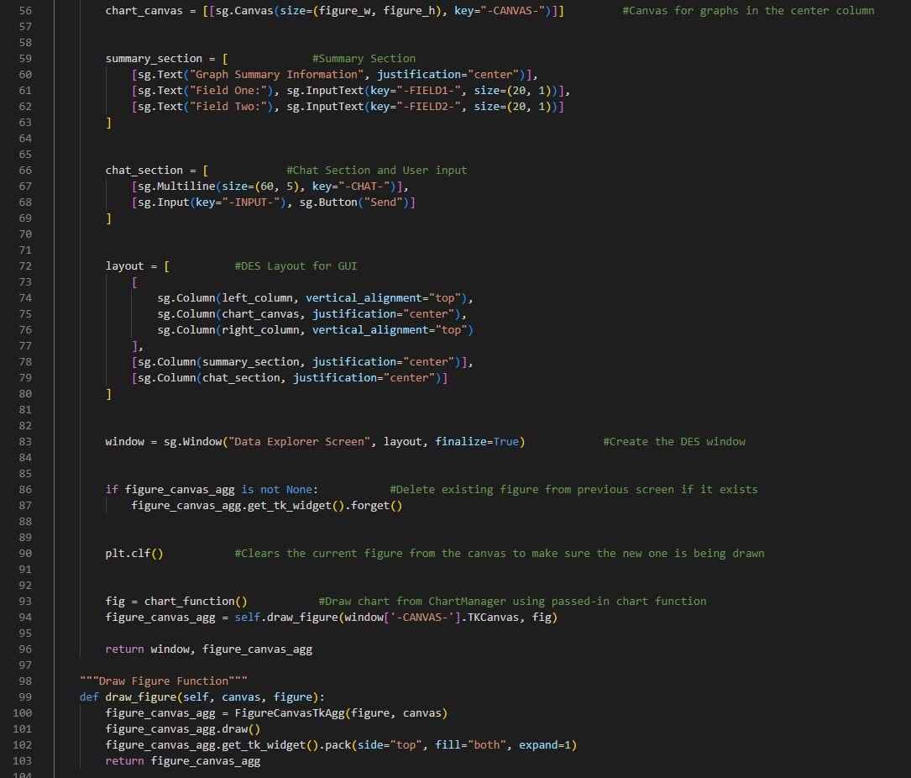

Windows.py Part 3

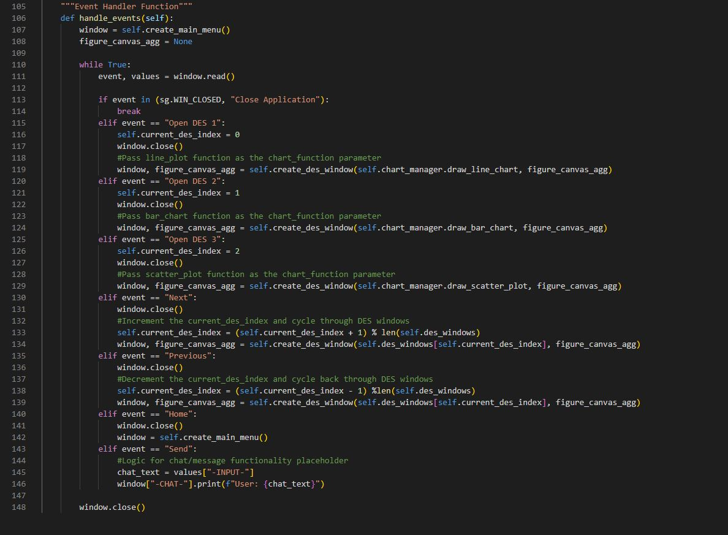

## Application Prototype Screens

Main Menu

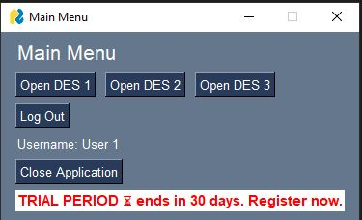

DES Screen 1

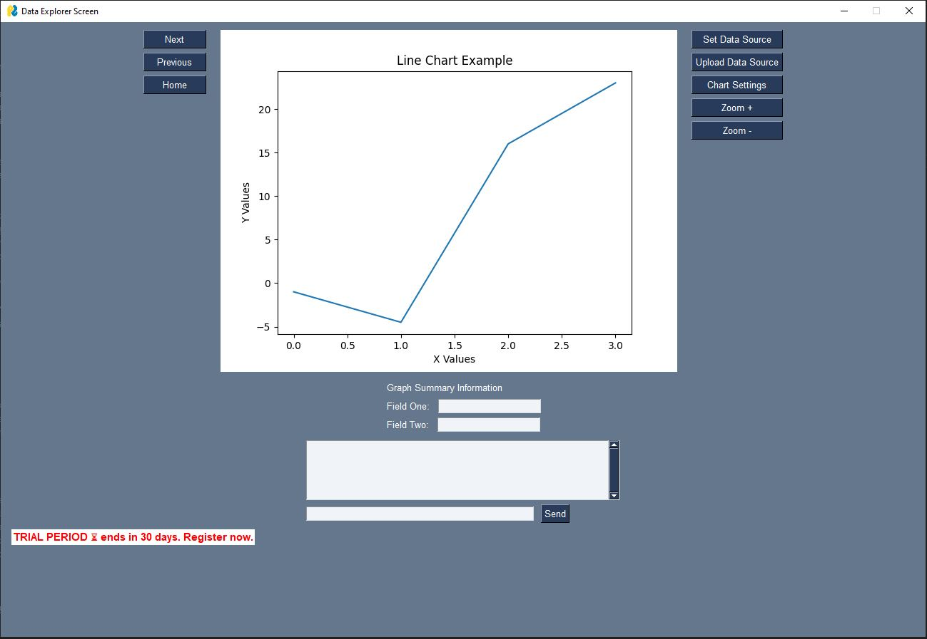

DES Screen 2

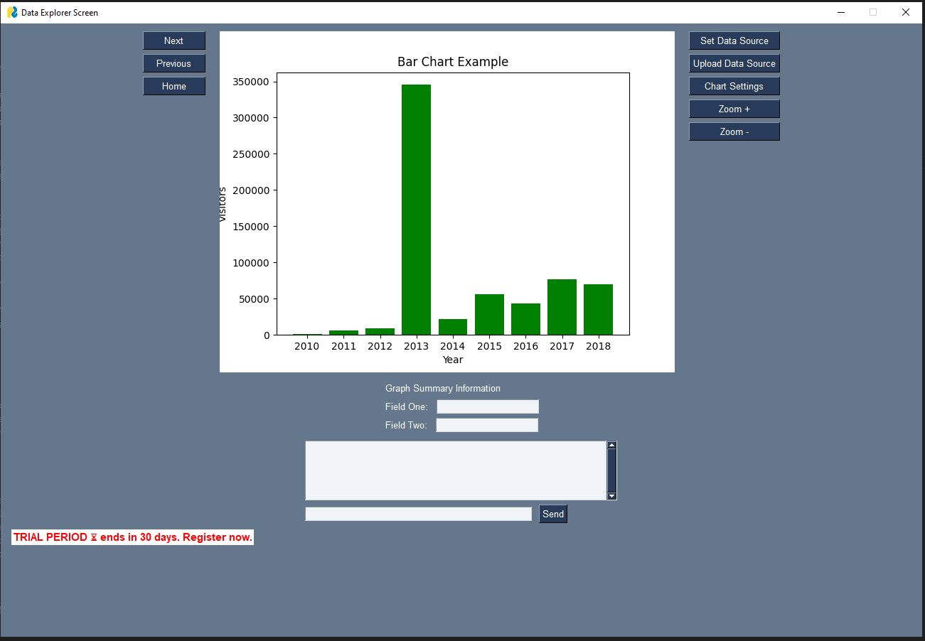

DES Screen 3

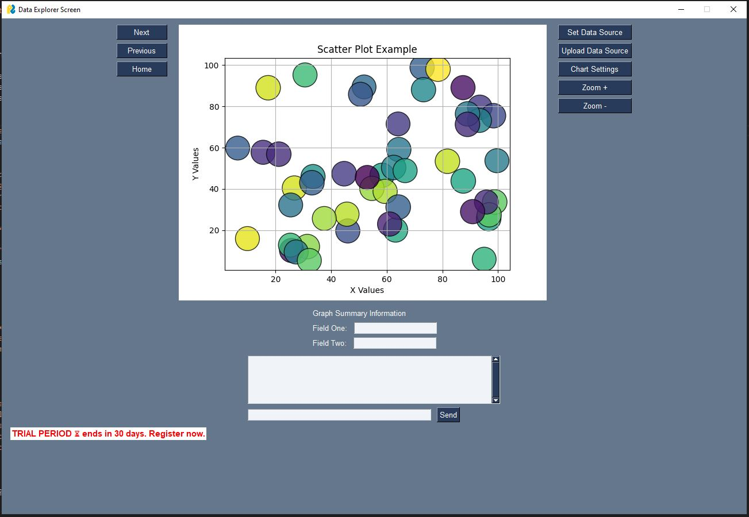

## References and Citations

Guido van Rossum <guido at python.org>, Barry Warsaw <barry at python.org>, Alyssa Coghlan <ncoghlan at gmail.com>. August 2013. PEP 8 – Style Guide for Python Code.

<https://peps.python.org/pep-0008/#introduction>

PySimpleGUI Team. 2024. PySimpleGUI Documentation.

<https://docs.pysimplegui.com/en/latest/>

Matplotlib Team. 2024. Matplotlib User Guide.

<https://matplotlib.org/stable/users/index>